Bahria University,

Karachi Campus



LAB EXPERIMENT NO.

**2**

LIST OF TASKS

|  |  |
| --- | --- |
| TASK NO | OBJECTIVE |
| 1 | Get the price of an order (by multiplying unit price by quantity). |
| 2 | Display all cities that employees belong to but don’t allow repetition. |
| 3 | Find complete name of all employees. |
| 4 | Display all the orders where unit price lies in the range of 10$ to 40$. |
| 5 | Display the company name where Region is NULL in Customer Table. |
| 6 | List all products where UnitPrice is not in 10,12,15,17 or 19. |
| 7 | Display the highest, lowest, sum and average UnitPrice of each Category, where highest UnitPrice lies in the range of 50$ to 100$. Label column as CategoryId, Maximum, Minimum, Sum and Average, respectively. (Table: Products) |
| 8 | From customers table, Count all customers is each region where region is not null. (Table: Customers) |
| 9 | Write a query to display the number of ContactName with same ContactTitle. Sort contact title in descending order. (Table: Customers) |
| 10 | Write a query that count all orders against each product id. No of orders should be greater than 50. (Table: [Order Details]) |
| 11 | List only those cities in which more than or equals to 2 employees are living. |

Submitted On:

Date: 22/03/2022

**Task 1 : Get the price of an order (by multiplying unit price by quantity).**

**Query:**

select unitprice*quantity as Price from [order details]

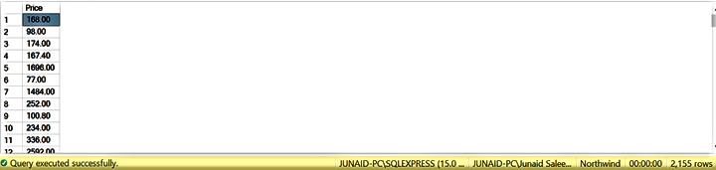**Output :**

**Task 2 : Display all cities that employees belong to but don’t allow repetition.**

**Query :**

select distinct city from employees

**Output :**

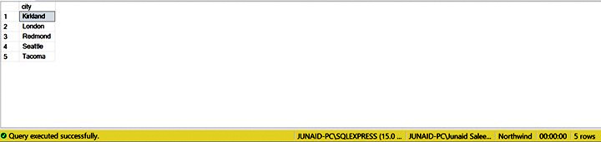

**Task 3 : Find complete name of all employees.**

**Query :**

select firstname+' '+lastname as [Full Name] from Employees

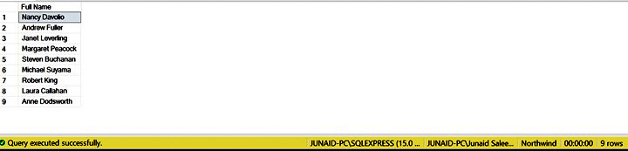**Output :**

**Task 4 : Display all the orders where unit price lies in the range of 10$ to 40$.**

**Query :**

select * from [order details] where unitprice between '10' and '40'

**Output :**

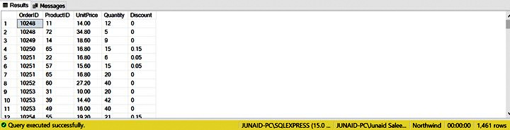

**Task 5 : Display the company name where Region is NULL in Customer Table.**

**Query :**

select CompanyName from customers where region is null

**Output :**

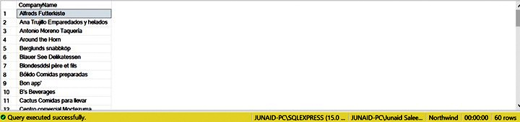

**Task 6 : List all products where UnitPrice is not in 10,12,15,17 or 19.**

**Query :**

select * from products where unitprice not in (10,12,15,17,19)

**Output :**

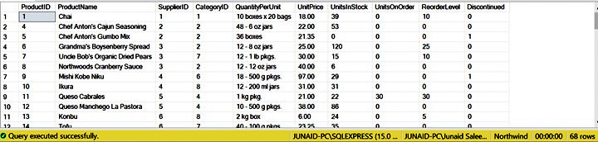

**Task 7 : Display the highest, lowest, sum and average UnitPrice of each Category, where highest UnitPrice lies in the range of 50$ to 100$. Label column as CategoryId, Maximum, Minimum, Sum and Average, respectively. (Table: Products)**

**Query:**

select CategoryID,Max(UnitPrice) as Maximum,Min(UnitPrice) as Minimum,SUM(UnitPrice)

as Sum,AVG(UnitPrice) as Average from Products group by CategoryID having Max(UnitPrice)

between '50' and '100'

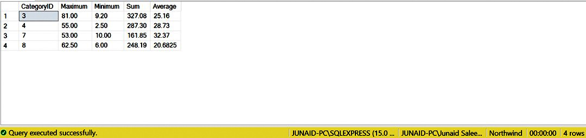**Output :**

**Task 8 : From customers table, Count all customers is each region where region is not null. (Table: Customers)**

**Query :**

select Region,count(CustomerID) as [No of Customers] from Customers where

Region is not null group by Region

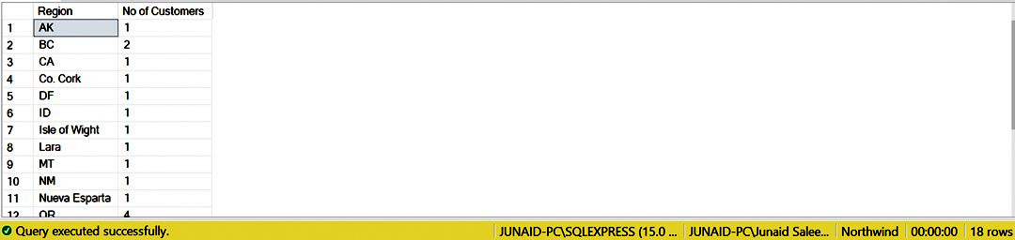**Output :**

**Task 9 : Write a query to display the number of ContactName with same ContactTitle. Sort contact title in descending order. (Table: Customers)**

**Query :**

Select ContactTitle,count(ContactName) as [Number of Contact Name] from Customers group by

ContactTitle order by ContactTitle DESC

**Output :**

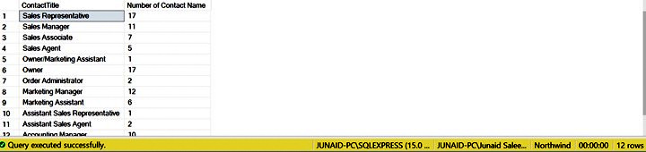

**Task 10 : Write a query that count all orders against each product id. No of orders should be greater than 50. (Table: [Order Details])**

**Query :**

select ProductID,Count(*) as [count orders] from [Order Details] group by ProductID

having count(OrderID)>50

**Output :**

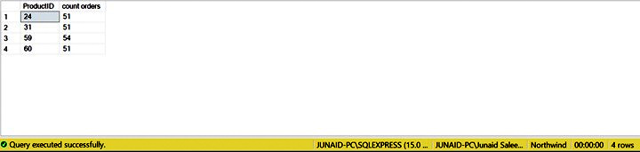

**Task 11 : List only those cities in which more than or equals to 2 employees are living.**

**Query :**

select City,COUNT(EmployeeID) as Employees from Employees group by City

having COUNT(EmployeeID)>=2

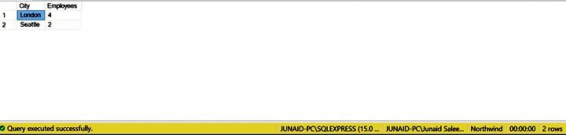**Output :**